Principle of Game Design

DM2116

Exercise 2

Done by:

142128G Ong Swee Seng

**Select a game of any genre or platform. Define the MDA framework of that**

**genre of game is. Use examples to support your point. Use screenshots too.**

**Plan and write down in point form or essay. However take note that the total**

**number of words should not exceed 200.**

**Your exercise should consist of the below:**

**1. 3 game mechanics**

**2. 3 game dynamics**

**3. 3 game aesthetics**

**You are not allowed to use graphical aesthetics more than once.**

**I have selected Assassin’s Creed IV Black Flag for the PC**

**1)Game Mechanics**

**a)Where there is 2 enemies,we can do a double assassination with either the hidden blade or the cutlass.**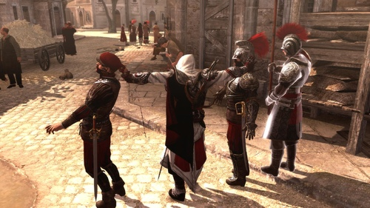

**b)Whenever we jump from a great height and did not land on a soft spot,we would lose a portion of our health or we would instantly desynchronized or game over depending on the height we jump from.**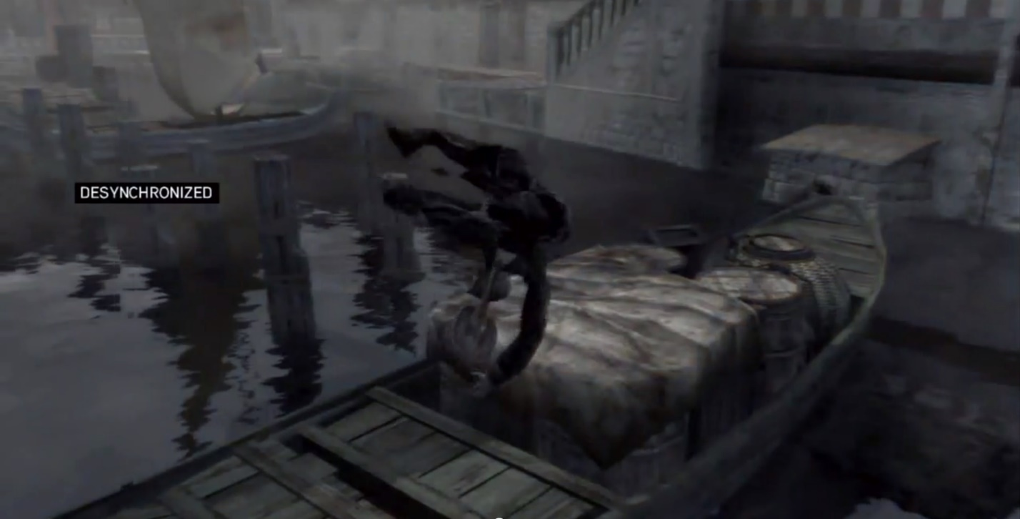

**c)When we board a incapacitate ship,we should have to eliminate a certain numbers of enemies before we can claim the ship for our own.**

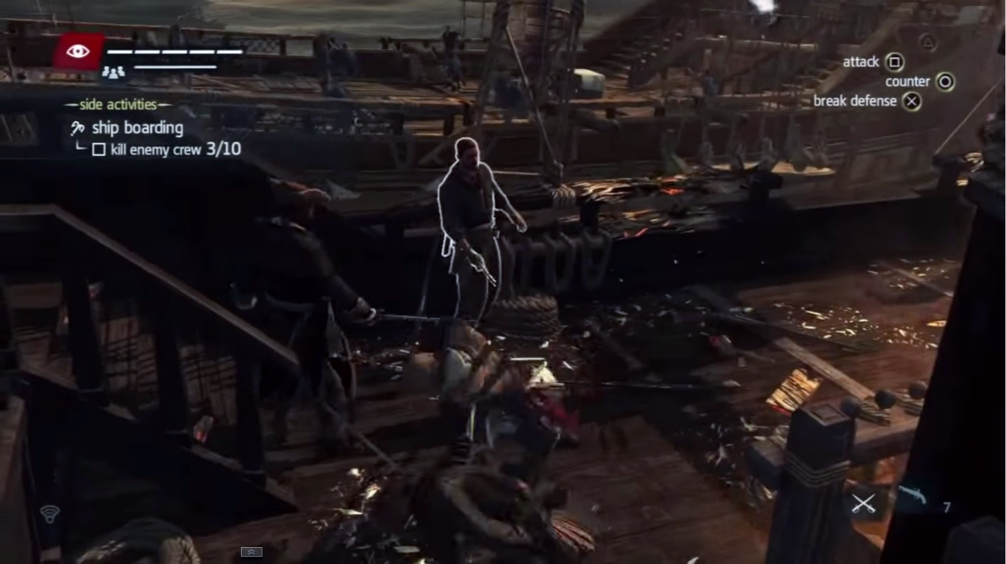

**2)3 Game Dynamics**

**a)When we shoot a gunpowder barrel,it would explode and a loud ‘bang’ sound is produced with a sudden burst of fire coming out.**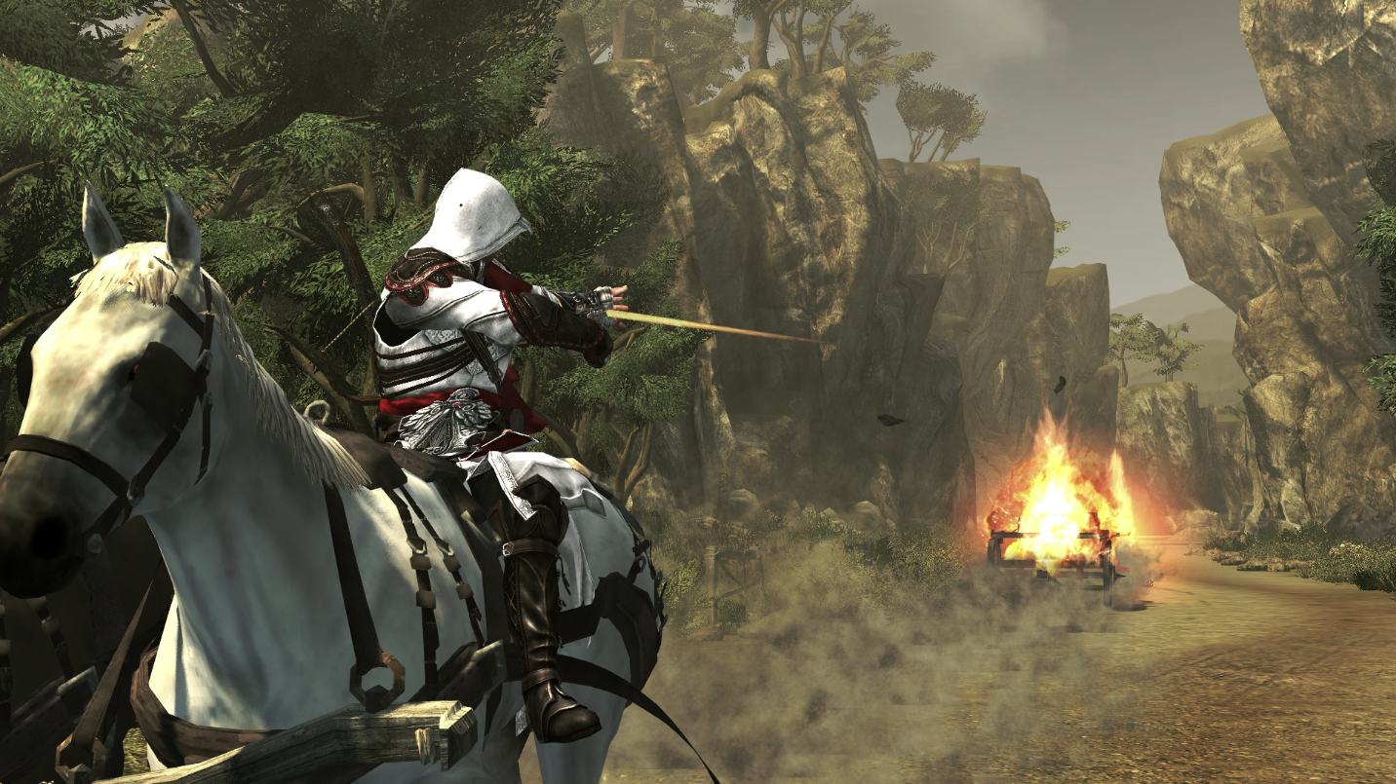

**b)We can jump off of a high structure and land, unharm into a cushioning material such as hay or water.It is also known as the leap of faith.**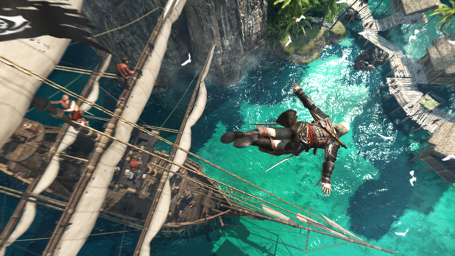

**c)In Assaassin’s Creed,when we use a smoke bomb,guards would act repulsive towards it,giving the players a better chance at killing them.**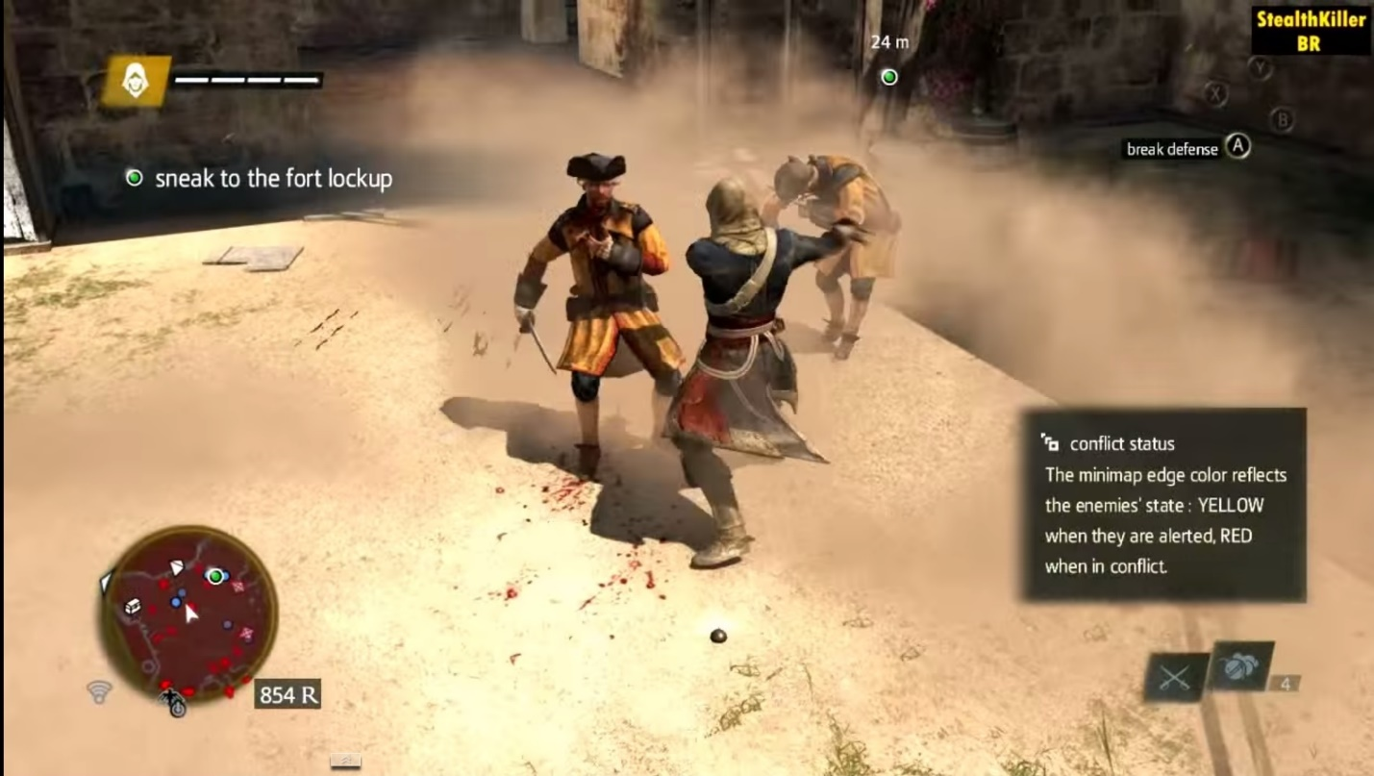

**3)3 Game Aesthestics**

**a)When it rains in the game,the ground will be wet as compared to older games where the ground will still be dry,adding a sense of realism.**

**b)In Assassin’s Creed,while we are hiding in dense vegetables,and while we are moving thought it,the vegetables themselves would move as we pass by them.**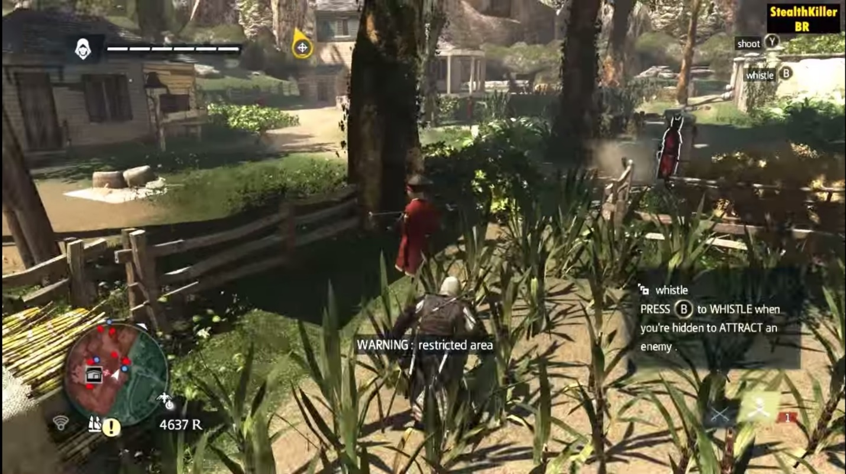

**c)In Assassin’s Creed,we can upgrade our avatar Edward Kenway with outfit,cutless or pistol.These upgrades can help players in the game with more power,stealth or immunity to bullets.**